METHACTON SCHOOL DISTRICT

HOME AND SCHOOL ASSOCIATION

TREASURER’S GUIDE

Fall 2010
Revised Spring 2016

MSD HOME AND SCHOOL (H/S) ASSOCIATION
TREASURER’S GUIDE (Spring 2016)

Table of Contents

Overview/Roles & Responsibilities……………………………………………… Section 1

Budget………………………………………………………………………………. Section 2

Spending Guidelines………………………………………………………………. Section 3

Accounting Duties & Procedures………………………………………………… Section 4

Audit………………………………………………………………………………… Section 5

Tax ID Information……………………………………………Reference Separate Electronic File

Standardized Forms…………………………………………Reference Separate Electronic File

Optional Forms………………………………………………Reference Separate Electronic File

MSD HOME AND SCHOOL (H/S) ASSOCIATION
TREASURER’S GUIDE (Spring 2016)
This guide was developed to assist H/S Treasurers and to add uniformity to the way the district’s H/S organizations conduct business. Many seasoned Treasurers contributed to this guide, drawing from a wide spectrum of experiences. Primary references for the guide are School Board Policy # 141 (which should be referenced often for specific organizational information), and Robert’s Rules of Order. Bylaws should also be referenced for further specific details. Any user of this guide is encouraged to consult with any current or past H/S Treasurer if there are questions about it’s content.
This guide should be reviewed periodically for potential updates or modifications. A work group is recommended for this type of review and update. The guide should be reviewed at least once every five years, as facilitated by the MSD Coordinating Council leadership.
Original Contributors: Tammy Ashliman, Lynette Becattini, Doreen Marberger, Deb Reid, LoriAnn Verna, Kim Woodring
Revisions by: Elizabeth Drummond and Gabby Winters

I. Role / Responsibilities of the Treasurer
The Treasurer is in charge of the finances for the local H/S Association. The key roles of the Treasurer are as follows:
- The Treasurer facilitates the budget development process, guides other Executive Board members through this exercise, and with the help of other key Executive Board members, prepares the budget for review and approval by the membership.
- The Treasurer manages the organization’s bank account, facilitating deposits and withdrawals, carefully recording transactions to create an accurate paper trail for future reference and auditing purposes. (The new Treasurer should examine the audit format as a first order of business to become familiar with the expectations and steps.)
- The Treasurer monitors the budget and provides a report, both written and verbal, at routine H/S meetings, and in response to other impromptu requests.
- The Treasurer organizes all financial records for the required annual audit. Outgoing Treasurers should ensure a smooth transition for the incoming Treasurer and provide training/mentoring as appropriate (both outgoing and incoming Treasurers should pay particular attention to and review the non-reconciled items as of June 30). The Treasurer role may NOT be shared as specified in the Bylaws.
II. Integrity
The Treasurer should handle all responsibilities with integrity. This is an extremely important role and all transactions must be documented properly for accurate reporting to the IRS and the PA Department of Revenue and ease of completing the audit at the end of the fiscal year.

III. Annual Financial Calendar Snapshot (Note: All timelines/dates are approximate)

JUNE 30 - Each H/S organization should begin to develop a preliminary budget for the next school year.
JULY 1 – H/S budgets are due to the MCC Treasurer.
JULY 15 – Books should be closed and prepared for audit. Quarterly financial report due to MCC Treasurer.
AUGUST 31 – Each H/S organization should have an annual audit completed and documented.
AUGUST/SEPTEMBER – Teacher letters with classroom budgets, if applicable, should be distributed along with Check Request and Deposit Forms (See Standardized and Optional Forms Sections).
SEPTEMBER – The budget should be presented to the whole H/S membership at the first scheduled meeting. Questions/comments should be entertained at this meeting. The budget is voted on and approved at the meeting.
SEPTEMBER/OCTOBER – Committee budgets should be distributed to committee chairs along with Check Request and Deposit Forms (See Standardized and Optional Forms Sections).
OCTOBER 15 – Quarterly financial report due to MCC Treasurer.
SEPTEMBER – MARCH - H/S financial transactions should be carefully monitored. In February, it is recommended a mid-year budget review be conducted by key H/S persons (this may be officers, chairpersons, the Principal, etc.) to ensure there is sufficient funding to meet program expenses as planned through the rest of the school year. If there is a surplus of funds, additional programs/activities can be considered and planned. See Spending Guidelines below.
JANUARY 15 - Quarterly financial report due to MCC Treasurer.
APRIL – If classroom budgets are being used, then reminder letters should be sent out to teachers indicating the balance of their classroom budget.
APRIL 15 - Quarterly financial report due to MCC Treasurer.
MARCH - JUNE – Execution of the budget continues with careful, ongoing monitoring. Financial reports should be presented in understandable terms at monthly H/S meetings.
JUNE 30 – This marks the end of the fiscal year for the district. Transactions should be closed out to ready the financial records for the annual audit.

Budget

School Board Policy #141
6. Budget - Each booster club/parental organization shall develop, no later than
June 30 of each fiscal year, an annual budget to be presented to the principal for
approval, and then to the membership of the organization for approval.
The budget shall clearly indicate the planned expenditures for the coming fiscal
year and shall demonstrate a reasonable balance between revenue and
expenditures. The budget shall also submit a list of all planned activities and
proposed dates.
- Bylaws should reflect those who should be involved to develop the preliminary budget. Generally, the Treasurer presents the last year’s final revenue/expense record (as well as the previous two years records, as necessary) to the President/s, Vice President/s, and other select members of the Executive Board (may include both incoming and outgoing board members).
- Careful review of the prior years’ budgets and actual expenses are useful in predicting budget amounts. The Treasurer should retain all documents used to formulate the budget and prepare the final budget document for approval.
- Each school needs to have a program in place for mini-grants for teachers and staff if they intend to provide items to teachers and staff. This program is separate from any classroom allocation programs that schools might have. Requests should be made using a formal application (See Standardized and Optional Forms Section). The school can determine how often to award the grants and for how much but the amount awarded must be included in the budget. Items requested should enhance the overall educational experience of the students and should not include supplies that the teachers and staff could obtain through the district.
- According to School Board Policy, budgets for non-profit entities should be formulated as “Zero-Based” (income and expenses offset one another).
- The budget should be discussed and approved at the first H/S meeting of the year.
- Please reference the chart below, which reflects the average budget allocations reported by district schools. This should not be used as a ‘stand-alone’ indicator or model, but rather a reference to consider when combined with other factors, such as changing enrollment and current economic climate. It is to be used as an example but the final budget allocation decisions are made by the H/S Executive Board. Please keep in mind that most expenditures should be directly related to the students or should enhance their overall educational experience. Administrative and Teacher/Staff Appreciation expenses should not be excessive.
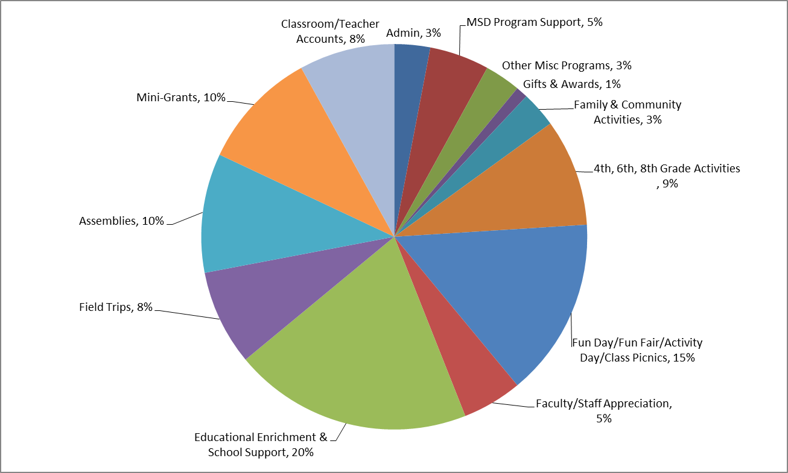

Spending Guidelines
Home & School’s funds should be spent on activities and programs that directly affect the students. Please keep in mind that most expenditures should be directly related to the students or should enhance their overall educational experience. Administrative and Teacher/Staff Appreciation expenses should not be excessive.
- H/S should have a formal mini-grant policy in place to address teacher/staff requests. When the budget is developed, a portion can be put aside for this. Individual H/S can determine the amount and how often they chose to administer the grants. The teacher/staff member should fill out the application with specific information on how the item will enhance the overall educational experience of the students (See Standardized and Optional Forms Section). Preference will be given to durable materials that enhance the curriculum or learning environment. The school Principal should approve the requests to be sure that the item is not something that the district could readily provide. All grant requests should be reviewed at a H/S meeting and voted on.
- Occasionally H/S will contribute to various philanthropic/charity events/programs. Cash donations should always be made to an organization, not an individual. In the case of a family hardship, gift cards or goods themselves are the preferred method of giving.
- Whenever possible, vendors should be paid directly by the H/S. Parent purchases and reimbursements are necessary for some activities. Items such as Yearbook, Fun Day/End of Year Events, Spirit Wear, etc. should be invoiced and paid directly to the vendor.
- According to School Board Policy, budgets for non-profit entities should be formulated as “Zero-Based” (income and expenses offset one another). However, H/S are permitted to keep a balance in their accounts at the end of the fiscal year. This amount should be no more than approximately 50% of their yearly operating budget. Beginning in February, Treasurers should review their budget. If they project a surplus of funds that exceeds approximately 50% of the operating budget, then the H/S needs to develop a spending plan. They could:
- Reach out to the Principal and see what plans or ideas the Principal may have for the school.
- Develop plans for a long range project where more funds need to be raised, then that money can be put in “Reserve”. A clear plan of how the money will be spent and the proposed time frame should be included.
- Plan a capital improvement/building improvement (should be approved by the Principal and Superintendent).
- Approve a portion of funds to be used for additional mini-grants.
- Some H/S offer their teachers/staff a classroom allotment. This should be used to purchase items needed for the classroom.

Accounting Duties & Procedures
Prior To Start of School Year

- Create or revise an introductory letter for each teacher/staff member to introduce yourself. Be sure to provide contact information. Include with the letter any pertinent information – classroom/grade-level/school program funds available, request for reimbursement/deposit forms, field trip form, mini-grant information, etc. (See Standardized and Optional Forms Section).

- Prepare information for all committee chairs – their expense/income budget, request for reimbursement/deposit forms, and the Treasurer’s contact information. Also provide information on where or to whom give deposits to and where to leave requests for reimbursement. It is important to have a secure place for deposits to be placed such as the school office safe. In addition, the Treasurer should provide the chair with any information that is needed to be reported at the conclusion of an event. (See Standardized and Optional Forms Section)

- Visit bank to obtain signatory privilege on all H/S accounts.

Accounting
- Generally, Treasurers prefer Quicken, QuickBooks, or excel software programs to facilitate their monthly accounting. H/S can keep their ledger in an electronic format or can even use a traditional check book to record their account deposits and withdrawals. The Treasurer should be comfortable with any system used to record their monthly transactions. The H/S organization should purchase the software, if necessary. H/S organizations may share software, when possible, and in accord with licensing criteria. All H/S will be required to report their financial position using a standardized excel file developed by the MCC.
- Bank Account Management (signature authority) - One bank account is usually sufficient for H/S business. TWO authorizing signatures on all checks are required in the interest of accounting integrity. If a check is issued to the Treasurer, two other authorized signers must sign the check.
- Keep records updated and organized. Key school officials may contact the Treasurer throughout the year for current account balances. The Treasurer is required to submit their spreadsheet to the MCC Treasurer quarterly. A money management system (QuickBooks, Quicken, etc.) enables the Treasurer to provide a detailed report very quickly. Electronically backing up programs on a bi-weekly basis is recommended so that no information is lost.
- Routine monitoring (monthly) - Reconcile bank statement. Keep in mind that some programs deposit funds directly into the account and will need to be manually entered into the money management system.

- For each H/S meeting, provide a Treasurer’s report. This report should minimally include an accounting of monies in the bank account, the current budget position, and monthly revenue and expenses. Also, be prepared at each meeting with a year-to-date transaction report in case there are any questions. Copies of these reports should be kept in the Treasurer’s Binder.

- Record Retention – Per the IRS, all financial records should be retained for a period not less than seven years.

Procedures
- Processing Transactions (deposits/withdrawals) - In terms of processing funds (checks and cash) for deposit, typically a two–week window is considered reasonable; likewise for reimbursements. Please note that this is from the time the Treasurer receives the funds and does not include the time the committee chair may retain the funds.
- Routine monitoring - The Treasurer’s mail area should be checked frequently. There is usually a place in the main office where all Treasurer mail/requests are kept. Also, monies to be deposited are typically given to one of the secretaries for safe keeping until the Treasurer picks them up for deposit. Copies should be kept of all invoices, requests, etc. and filed. Filing receipts/invoices chronologically is common and provides an easy way to stay organized.
- All payments/reimbursements should always be in the form of a check and should include supporting receipts/invoices. Tips can be made in cash when necessary. Funds should NEVER be electronically transferred.
- Problem Solving (bounced checks, non-payment, lost receipts, etc.) - Occasionally, a check may be returned for NSF (not sufficient funds). If this happens, it should first be noted in the money management program (Quicken, QuickBooks, etc.) under the appropriate category. Make sure to record any fees accessed by the bank. The Treasurer should send the family a letter to request the appropriate cash or money order (or replacement check if funds are now available) including any fees that may have been incurred. If there is still no response, forward the issue to the committee chairperson and H/S President.
- Whenever possible, vendors should invoice and be paid directly by the H/S. Parent purchases and reimbursements are necessary for some activities. Items such as Yearbook, Fun Day/End of Year Events, Spirit Wear, etc. should be paid directly to the vendor.

Audit

School Board Policy #141
5. Annual Financial Audit - Each organization shall have its financial records
audited yearly by an auditor or audit committee approved by the Methacton
School District’s Business Manager in consultation with the Superintendent. Said
audit shall be conducted after the completion of the organization’s fiscal year and
shall be submitted to the district prior to August 31.
The annual audit should be performed to validate the H/S program, in general, with three basic objectives in focus:
- The budget should generally reflect the mission / objectives of the local H/S program, as defined in the by-laws.
- The accounting process should provide a clear paper trail of all financial transactions.
- There must be integrity in all aspects of financial management and reporting; all reports should reconcile with ledgers, bank statements, and transaction paperwork (order of checks, for example) must be authentic.
The financials of all Methacton Home & Schools will need to be audit by independent CPA. Please see the regulations below. The Treasurer of the MCC will coordinate the audits.
Pennsylvania Audit Required: Yes Statute and Description: 10 Pa. Cons. Stat. §162.5 (f) | A charitable organization with annual contributions of $300,000 or more must file an audited financial statement prepared by an independent CPA. A charitable organization with annual contributions less than $300,000 and at least $100,000 must file a financial statement that is reviewed or audited by an independent CPA. A charitable organization with annual contributions less than $100,000 and at least $50,000 must have a compilation, review, or audit of its financial statements prepared by an independent CPA. - See more at: https://www.councilofnonprofits.org/nonprofit-audit-guide/state-law-audit-requirements#sthash.80WYbI8D.dpufA single person or a team may perform the audit.

REFERENCE TERMS USED IN AUDITS:

Balance Sheet – A statement of financial position at a specific date. Reflects assets (including cash), liabilities (amounts owed to others), and equity (including reserves and/or retained earnings).
Bank Reconciliation – A report, which reconciles the Bank Statement cash balance to our “Book” Balance.
Bank Validation – An electronic stamp on a banking receipt that reflects bank processing; typically includes date and amount.
Book Balance – Cash balance according to the Cash Ledger, and reported on the Treasurer’s Report. Quicken calls this the “Register Ending Balance” on its Bank Reconciliation Report.
Cash Ledger – A running record of the cash balance, which includes details of all transactions (deposits, payments, etc.) Can be a checkbook, an actual ledger book, or a software program (Quicken, QuickBooks).
Balance Sheet – A procedure which helps identify any increases or decreases in the cash balance that were not reported in the Income Statement and/or transaction listings. (See sample Balance Sheet included with audit program).
Income Statement – A statement of financial results for a specific time period (e.g., month, quarter, year), which may be included in the Treasurer’s Report. Reflects income, expenses and net income/(expense) for the period. May include line items for each fundraiser, program and/or committee. May also be called a P&L (Profit & Loss Statement) or Earnings Report.
Net Income/(Expense) – Total income minus total expenses; referred to as “net income” if income is greater than expenses, or “net expense” if expenses are greater than income. Parentheses are often used to indicate that a number is an expense.
Operating Funds – Cash received or paid for operating activities of H&S that are not reserved for a specific purpose.
Reconciling Items – Outstanding or unprocessed transactions. Checks and Deposits pending processing are two types of reconciling items.
Reserve Funds – Cash reserved for a specific purpose; record keeping is separate from Operating Funds.
Treasurer’s Report – Report prepared monthly by the Treasurer and presented to the Executive Board, Principal, and H&S membership at H&S meetings. May include (1) a monthly summary of income and expenses by program/committee, (2) cash balance (including Operating and Reserve Funds), and (3) any liabilities (amounts owed to others; for example, cash balances maintained for School Programs). May include a formal Balance Sheet and Income Statement.
Transaction Listing – Detailed list of deposits, payments and any other transactions processed, reported by month and/or cumulative for the year. May be from a financial software program (Quicken, QuickBooks), a spreadsheet (Excel), or handwritten. Cash Ledger or checkbook can serve in place of Transaction Listing (not required).
Outstanding Checks – Checks written but not yet cashed and cleared through bank.
Deposits in Transit – Amounts deposited but not reflected in the bank statement.

